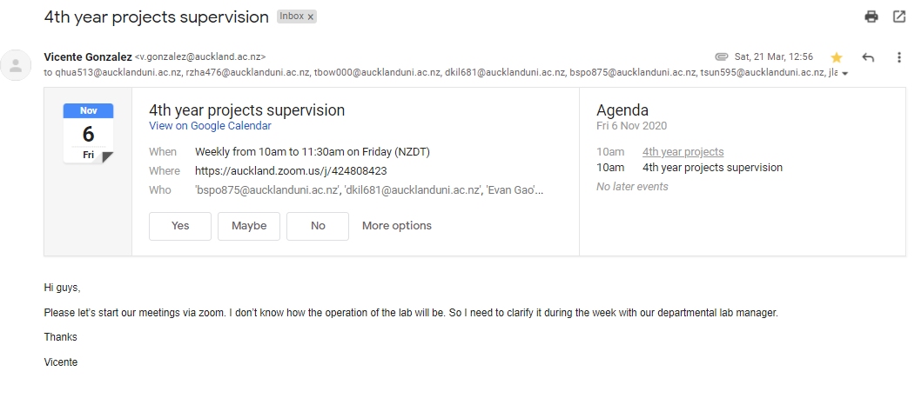

Throughout the year, we had weekly meetings with our supervisor, Vicente Gonzalez, every Friday at 10am.

Meetings were usually a chance for Vicente to check on the progress we were making, to make sure that we were still on course to finishing on time. The meetings also provided us with the opportunity to ask any questions about the project.

Meeting Summaries:

6th March:

In person meetings, with Nasser present as well. We were given a run down of how the process would work, and what was expected of us throughout the year.

13th March:

In person meeting. We had a couple of questions about how to open last year’s project on unity.

20th March:

Last in person meeting before lockdown. We had a safety briefing for the Smart digital labs. We managed to open up last year’s project, but still weren’t sure how to get coding. We were told that we would need to have the Microsoft HoloLens Device to see what it looked like.

27th March:

3rd April:

10th April:

No Meeting due to being good friday

17th April:

24th April:

After lockdown, it was uncertain whether we would be able to access the labs to continue to use the Microsoft HoloLens. Therefore, the scope of our project was changed to perform the same experiment as last year but to use smartphone AR instead of making multi user HoloLens AR.

1st May:

Progress Report: We had begun looking into different types of software and add-ins to unity that allow augmented reality on smartphones.

8th May:

Progress Report: Have chosen to try and use AR foundation because it allows the developer to make one app that will be usable for both android and ios devices, which was necessary as one of us had a mac and the other had a windows laptop, and only macs can build to iphones, and windows can only build to android devices.

We also submitted our ethics application after much revising and fixing with the help of some of the ethics advisors (Elizabeth Visser).

15th May:

Progress report: We were able to create a very simple application for iphone that had the ability to detect planes and surfaces that were in the camera’s view.

22nd May:

Progress Report: We were able to further develop the application so that cubes could be spawned onto real life surfaces.

29th May:

Progress Report: We were able to import the model from last year into the app we created, so that the model could be placed onto real life surfaces.

5th June:

Progress Report: We were able to add a function that enabled the user to move the model around using their finger.

12th June:

Progress Report: We were able to add a rotate function that let the user rotate the model around using two fingers.

19th June:

Progress Report: We were able to add a zoom function that allowed the user to enlarge and diminish the model using a two finger pinch movement on screen.

26th June:

Progress Report: We were able to get our hands on a university android device to test out the app. However, we found that the android devices camera was not as advanced as the one we had been testing the app on, which was the latest iphone, with 3 cameras. The android therefore had trouble detecting surfaces, as there was only one camera which makes depth detection very difficult. Therefore we switched to using vuforia, which uses real life image targets that cameras could identify and track, so the phone knows where the model should be in relation to the image target.

3rd July:

Could not attend Meeting due to exam

10th July:

Progress Report: We were able to change the type of software used with Unity to Vuforia instead of ARFoundation. However, we had to re import the model and re apply the functionalities that we had previously added. However, it was much easier to do this a second time as we kind of knew how to do it already.

17th July:

Meeting Cancelled

24th July:

Progress Report: We were able to add the highlight function to the app,

31st July:

Progress Report: We were able to add the delete button. We also ran some pilot trials to get some feedback on the app to see if any areas need improvement.

7th August:

Meeting Cancelled

14th August:

Progress report: We were able to add the undo buttons and the hide UI buttons, which pretty much meant the completion of the app. The hide UI button was an improvement that was suggested in a few of the pilot trials.

Monday 18th August:

Meeting with Nasser - We discussed how to change our experiment method so that it could be done online. We also discussed potentially aiming to test the prototype qualitatively instead of relying on obtaining 30 participants, as our trial would be quite tedious to complete. We decided to briefly look into it as a backup plan if we failed to get at least 30 participants.

21st August:

We asked about the ethics application which was having some issues. Vicente told us to send another email to Colleen from the ethics committee. The issue was resolved that day after sending an email.

28th August:

Progress Report: We were ready to start our trials and prepared the advertisement and trial material, and made sure that the testing procedure was appropriate

4th September:

The advertisement email was sent out to engineering students, and we began to receive expressions of interest.

11th September:

The trials were underway with about 10 being completed.

18th September:

Meeting Cancelled

We had done more trials, approximately 20 at this point

25th September:

Progress Report: we have gotten 32 participants to do our experiment, which was greater than the generally accepted 30.

2nd October:

Meeting Cancelled - Vicente on Annual Leave

9th October:

Meeting Cancelled - Vicente on Annual Leave

16th October:

Short Meeting - Asked if we could send a draft report to get feedback. He said yes send it Monday morning.

23rd October:

Meeting Cancelled

30th October:

Meeting Cancelled